Bimboola Activity

First, we are going to ask you to do an imagination and simulation exercise. We want you to imagine that you are another person in different circumstances, which we will describe to you. The exercise consists of stepping into the role of a character that we have randomly assigned to you.

From this point on, you are part of a virtual society called Bimboola, and you must organize your life as a member of this society. You should know that, like in any other society, in Bimboola there are also differences in economic income among the citizens of Bimboola. Specifically, the citizens of Bimboola are divided into 5 income groups:
Group 1 earns less than 400 € Bimbolianos (EB) per month (they are below the poverty line),
Group 2 earns between 400 and 1,200 EB per month,
Group 3 earns between 1,201 and 3,000 EB per month,
Group 4 earns between 3.001 y 100.000 EB per month, and,
Group 5 earns more than 100,000 EB per month.

----------------
SCARCITY CONDITION

You have been randomly assigned to belong to income Group 1, and now we ask you to begin organizing your life in Bimboola knowing that you earn less than 400 EB per month.
-----------------
SUFFICIENCY CONDITION
You have been randomly assigned to belong to income Group 3, and now we ask you to begin organizing your life in Bimboola knowing that you earn less between 1,201 and 3,000 EB per month.

Your first task will be to get settled, so you will need to find a house, a car, and a phone. You will also be able to choose a spot for a vacation. Please keep in mind that you can only choose goods that belong to your income level or a lower one.

[Page break]

Please select the place (mansion, house, apartment, or room) that you want and can afford to live in Bimboola. Don’t forget that you belong to the economic Group X (dependent on the condition, Grupo 1 or 3), and that you can only choose goods from your own income level or from a lower one.

 |   Group 5 |  |   Group 5 |  |   Group 5
 |   Group 4 |  |   Group 4 |  |  Group 4
 | 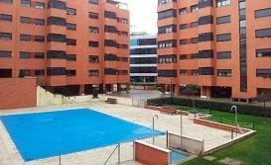 Group 3 |  |  Group 3 |  |  Group 3
 |   Group 2 |  | 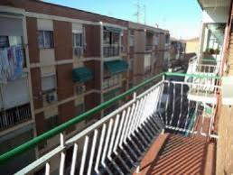  Group 2 |  | 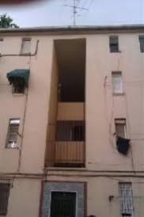  Group 2
 | 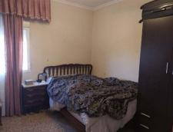  Group 1 |  | 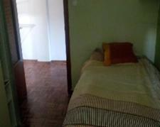  Group 1 |  | 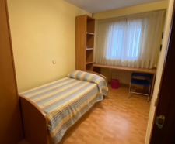  Group 1
[Page break]
Please, select a vehicle to get around Bimboola, do not forget that you are in economic Group X (dependent on the condition, Grupo 1 or 3) and that you may only choose goods from your own income level or from a lower one.

 | 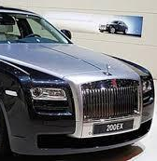  Group 5 |  |   Group 5 |  |   Group 5
 |   Group 4 |  |   Group 4 |  |   Group 4
 |   Group 3 |  | 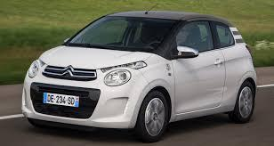  Group 3 |  | 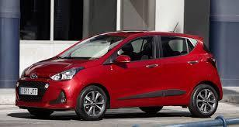  Group 3
 | 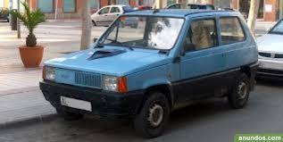  Group 2 |  | 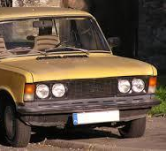  Group 2 |  | 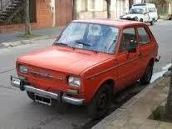  Group 2
 | 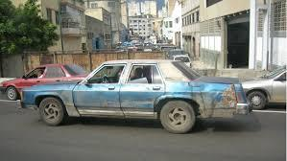  Group 1 |  | 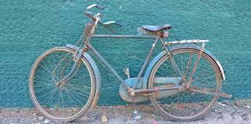  Group 1 |  | 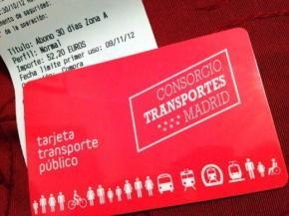  Group 1

[Page break]

You will also need a telephone to be able to communicate with your friends in Bimboola, please, choose a telephone considering that you can only choose goods from your own income level or from a lower one.

 |   Group 5 |  |   Group 5 |  |   Group 5
 |   Group 4 |  |   Group 4 |  |   Group 4
 |   Group 3 |  |   Group 3 |  |   Group 3
 |   Group 2 |  |   Group 2 |  |   Group 2
 | 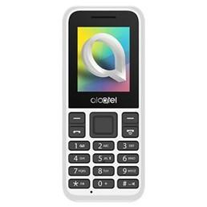  Group 1 |  | 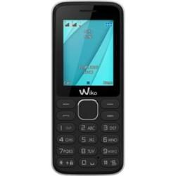  Group 1 |  | 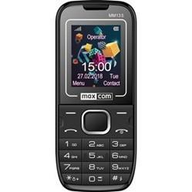  Group 1
[Page break]

You have worked a lot this year and you have some vacation days. Your next task to is choose a vacation option. Remember that that you can only choose a vacation from your own income level or from a lower one.

 |   A month on a private island  Group 5 |  |   A space tourism trip  Group 5 |  |   A tour through several exotic countries  Group 5
 |   An adventure in a 4x4 for a month in Asia  Group 4 |  |   One month in your favorite city  Group 4 |  |   An African safari  Group 4
 | 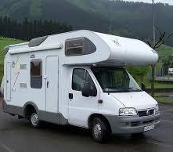  A trip in a campervan  Group 3 |  | 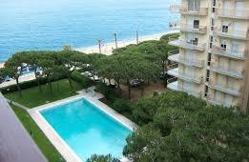  A week at the beach  Group 3 |  |   A week in a cabin  Group 3
 | 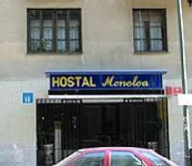  A weekend in a hostel  Group 2 |  |   A weekend camping  Group 2 |  |   A day trip to a small town  Group 2
 |   An afternoon relaxing in a park  Group 1 |  |   A walk in the center of your city  Group 1 |  |   An afternoon in your municipal pool  Group 1

[Page break]

Please indicate how many Bimboolian Euros (EB) you earn in your social group in Bimboola:
- Less than 400 EB per month
- Between 400 and 1,200 EB per month
- Between 1,201 and 3,000 EB per month
- Between 3,001 and 100,000 EB per month
- More than 100,000 EB per month

[Page break]

Please indicate the extent to which you agree or disagree with the following statements:

In Bimboola, my social group is poor
1.  Totally disagree | 2 | 3 | 4 | 5 | 6 | 7.  Totally agree
In Bimboola my social group is rich.
1.  Totally disagree | 2 | 3 | 4 | 5 | 6 | 7.  Totally agree

